Lab Sheet 2

Name : Lokesh Chandra Basu
E.No. : 10114026
Course : Operating Systems Lab

Question 1

Design and implement a Scheduler using a non-preemptive Shortest Job First (SJF)
algorithm.

Algorithm

Algorithm used :

//to create the Job Queue
take input from the user for the number of queues in each of the Job Queue
Initialize count to 0
While count is less then input number
generate a random number to be stored in queue as pID
count = count +1

//to move processes from the Ready Queue to Running Queue base on their
Burst Time

if same arrival time
search for the shortest Burst Time among all the processes and then
move it to the Running Queue and so on
else
search for the shortest Burst Time from Waiting Queue and also from
ready Queue ab then move that process into Running Queue

do not terminate the program unless the Waiting Queue and Ready Queue are
both empty

Gantt Chart
Procees Execution Tiem(in ms)
P1 5
P2 15
P3 10
P4 7
P5 3

Job Queue with processes and execution time (assuming all arrives at same time) :

P1 | P2 | P3 | P4 | P5

After Long Term Scheduler or Job Scheduler :
Ready Queue :
P5 | P1 | P4 | P3 | P5
0 3 8 15 25 40
time elapse = 0ms

After Short Term Scheduler or Scheduler Dispatch :
Ready Queue :
P1 | P4 | P3 | P5
3 8 15 25 40

Running Queue :

P5
(Running)
0 3

time elapse = 3ms

After Short Term Scheduler or Scheduler Dispatch :
Ready Queue :
P4 | P3 | P5
8 15 25 40

Running Queue :

P5  (Terminated) | P1(Running)
0 5 20

time elapse = 20ms (just after P2 terminates) And So on...
Output

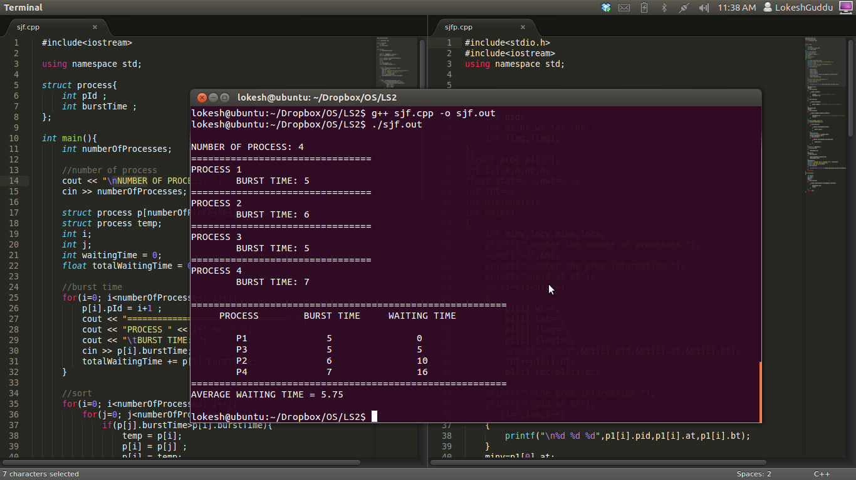
gcc version 4.6.3 (Ubuntu/Linaro 4.6.3-1 ubuntu5)

Question 2

Design and implement a Scheduler using a preemptive Shortest Job First (SJF)
algorithm.

Algorithm

Algorithm used :

//to create the Job Queue
take input from the user for the number of queues in each of the Job Queue
Initialize count to 0
While count is less then input number
generate a random number to be stored in queue as pID
count = count +1

//to move processes from the Ready Queue to Running Queue base on their
Burst Time

if same arrival time
search for the shortest Burst Time among all the processes and then
move it to the Running Queue and so on
else
search for the shortest Burst Time from Waiting Queue and also from
ready Queue ab then move that process into Running Queue

do not terminate the program unless the Waiting Queue and Ready Queue are
both empty

//applying preemptive SJF
if different arrival time
then if any process in Waiting Queue or Ready Queue has less Burst
Time then the time left for execution of the process in the Running Queue
then remove the process from Running Queue and move it into Waiting
Queue and move the shortest process into Running Queue.

Gantt Chart

Procees Execution Tiem(in ms) Arrival Time(ms)
P1 5 0
P2 15 0
P3 10 5
P4 7 10
P5 3 20

Job Queue with processes and execution time (assuming all arrives at same time) :

P1 | P2 | P3 | P4 | P5

Processes Queue after Termination Queue :

P1 | P3 | P5 | P4 | P2
0 5 15 18 25 40

Output

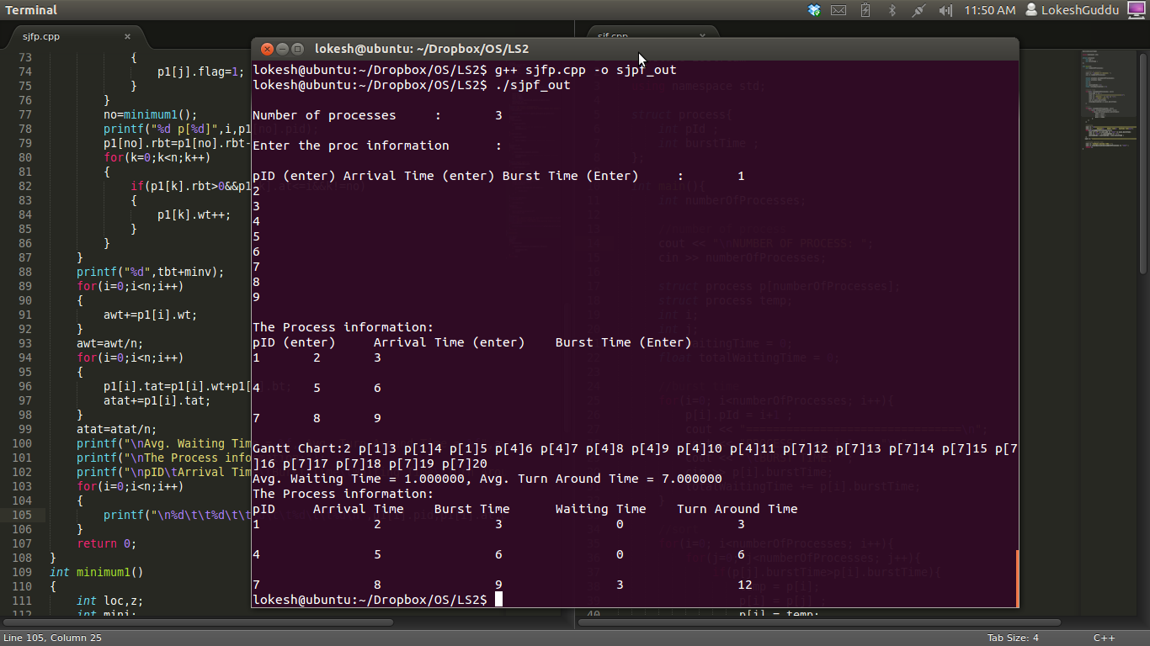
gcc version 4.6.3 (Ubuntu/Linaro 4.6.3-1 ubuntu5)

